**Derivation of Supply Curve of PV ~**

**Impact of Setback regulation ~**

Seungho Jeona, Gildong Hongb, Gyeonggi Dob,[1]*

a *Climate & Environment Data Center, Gyeonggi Research Institute, South Korea*

b *Climate & Environment Data Center, Gyeonggi Research Institute, South Korea*

**Abstract**

This is an abstract.

**Keywords:** Keword1, Keword-2, Keyword-3

1. Introduction

전세계 속에서 우리나라 특성 온실가스, (신재생)에너지 등

우리나라에서 경기도 특성: 온실가스, (신재생)에너지

신재생 도입을 방해하는 요소: 1.2.3….Setback

Setback에 대한 전세계 현황

Setback에 대한 우리나라 현황: Setback 규제가 생겨난 이유, Setback의 종류 등등

Objective:

1) explore suitable sites for PV deployment. (GIS-based approach)

2) scenario analysis (No Setback vs. Setback)

3) Supply curve

Comparison of PV energy potential

4) Compare supply curve of PV (LCOE assumption)

4)

sssssssssssssssssssssssssssssssssssssssssssssssssssssssssssssssssssssssssssssssssssssssssssssssssssssssssssssssssssssssssssssssssssssssssssssssss

Fig. 1. Study Design

1. Methodology
   1. GIS-based approaches

Land-use types are categorized.

# 9가지 유형별 대표 사진

|  |  |  |
| --- | --- | --- |
|  |  |  |
|  |  |  |
|  |  |  |

Fig. 2. Representative examples of PV installation across nine land-use types.

* + 1. Industrial complex

- 산업단지 정의 및 유형 설명.

- 산업단지를 골라낸 방법

* + 1. Logistics complex

- 물류단지 정의 및 유형 설명.

- 물류단지를 골라낸 방법

* + 1. Residential complex
    2. Public buildings
    3. Mountainous area
    4. Farmland
    5. Parking lot
    6. Roadside land
    7. Water

Table. 1. Summary of land-use types

|  |  |  |
| --- | --- | --- |
| Land-use type | Description | Data source |
| Industrial complex |  |  |
| Logistics complex |  |  |
| Residential complex |  |  |
| Public buildings |  |  |
| Mountainous area |  |  |
| Farmland |  |  |
| Parking lot |  |  |
| Roadside land |  |  |
| Water |  |  |

* + 1. Geographical constraint

법적, 지형적 규제를 검토한 사항들에 대한 설명.

- (농지) 농업보호구역, 농업진흥지역

- (산지) 보전산지, 경사 15도.

- (전체) 이격거리

* 1. Calculation of PV potential

Annual theoretical potential generation of PV in the given area ( in m2) is calculated as the global horizontal irradiation ( in kW/m2) as followings.

The theoretical potential is limited to deliver meaningful information to policy makers. Geographical and technical constraints would be taken into account when we try to find more realistic estimation for the PV potential. The geographical and technical potential would be calculated as followings.

Here, (in kWh/m2) is geographical and technical generation potential under geographical (ex. protected area) and technical constraints (ex. PV module efficiency). (unitless) is generator-to-system area ratio, which is the ratio of the area occupied by the PV generator (including PV arrays and the spaces between them) to the total suitable area available for the PV system. It indicates how efficiently the available area is utilized for placing PV systems. (unitless) is the packing factor, the ratio of the total PV array area to the land area PV arrays occupy. It measures how densely the PV arrays are packed within the occupied space. (unitless) is the performance ratio, the ratio of the actual generation achievable in practice to the ideal generation under no-losses conditions. Regardless of module efficiency and shading effect, it measures PV system losses from array temperature, surface soiling, panel degradation etc.[2] is the module efficiency. is the shading factor.

In this study, instead, the reduced formula is applied as followings.

would be called Land occupancy factor [1].

Elkadeem et al. (2022)는 나랑 똑같이 2개 (Ratio, Coef)로 나누어서 했네.

Where (kWh/year) is generation potential of PV in Gyeonggi province. is an individual site, is a city& county, is a type of PV technology, is a type of land-use. (kWh/year) is generation potential at an individual site. (m2) is the area of the individual site. (unitless) is the land-use ratio, which represents the ratio of the land area used for a PV system. (m2/kW) is the land coverage ratio, which represents the ratio of land covered by a PV system. (unitless) is the capacity factor of a PV system.

Data for the area of individual site is obtained from GIS-based approach as previous section describes. XX% (XXm2) of the total Gyeonggi province area (XXm2) is explored which counts totally 100,000 individual sites. Data for the land-use ratio is calculated using actual PV installation cases data, or in some cases, are assumed, depending on the land-use types. As a rooftop PV case, 54.5% of the individual site area is utilized for a PV system on average in industrial complex, logistics complex, residential complex, and public buildings. The land-use ratio for the mountainous area and farmland are assumed to be 40% and 5% respectively. In parking lot and roadside land, 18.9% and 28.4 % of the individual site area is utilized for a PV system respectively. Data for the land coverage ratio is calculated using the actual PV installation cases data as well. Unlike the land-use ratio, land coverage ratio is applied depending on the PV technology types. For the case of roof-top PV, 7.23m2 is required for a PV system of 1kW capacity. For the one of ground-mounted PV, 11.50m2 is required for a PV system of 1kW capacity. Data for capacity factor is obtained from XX, which is calculated based on the actual power market data. The capacity factor is applied differently depending on the city& county where the individual sites are located.

While the land-use ratio for the roof-top PV cases is applied as the average on the four land-use types, the one for the ground-mounted PV cases are applied differently depending on each land-use type. The land-use ratio for the mountainous area and farmland are assumed to be 40% and 5% respectively.

is

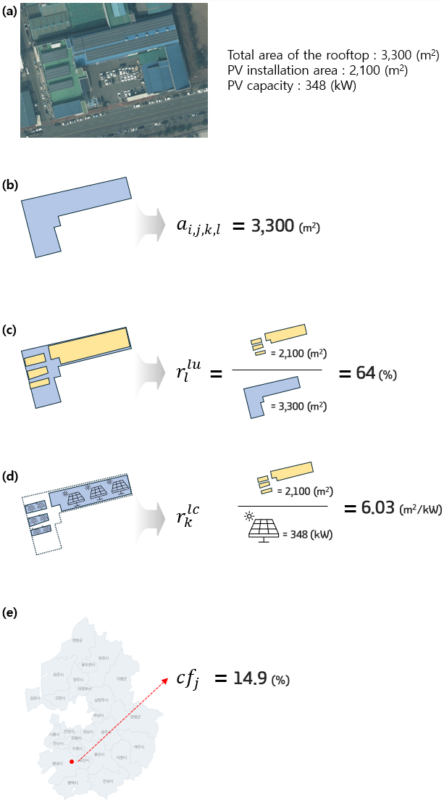

Fig. 3.

Ratio 근거논문

Saraswat et al (2021): Area factor, maximum land area covered by the PV panels with the minimum shading effect : 70% (based on previous studies)

Dhunny et al. (2019): Area factor which indicates the fraction of calculated area that can be filled with solar panels.: 70%

Ground Ratio는

Ouchani et al. (2021): Ground Coverage Ratio: 20%

IRENA (2014): Ground Coverage Ratio: 20%

오명찬 (PhDThesis) Table5.2

* 1. Assumption of LCOE

LCOE assumption from KEEI. Draw a graph.

* 1. Scenario

|  |  |
| --- | --- |
| Scenario | Description |
| No Setback | PV generation potential without Setback regulation |
| Setback | PV generation potential under Setback regulation |

Land cover ratio: Martin-chivelet (2016) generator to system ratio(GSR) : 0.7 ~ 0.85

Coefficient >> LCR (Land Coverage Ratio)

Vyas et al. (2022), Land Cover Ratio (LCR) : 12.95(m2/kW) : Land Coverage Ratio, which is the ratio of land area occupied by the structures (which becomes unusable for any other purpose) to the total land area available at the project site(area occupied by structure/foundation of SPV tree can be seen in graphical representation in Fig3.))

Land Occupation Factor (LOF) : Yushcenko et al. (2018)

Power-based direct land use : Martin-Chivelet (2016)

Ratio >> ELR이라고 명명하자. (Effective Land Ratio)

|  |  |  |  |  |  |  |  |
| --- | --- | --- | --- | --- | --- | --- | --- |
| Explored suitable sites for PV | | | Applied parameters | | | | LCOE |
| Land-use type | Area (m2) | Number of sites | PV type | Ratio (%) | Coefficient (m2/kW) | Capacity factor |
| Industrial complex | 25,293,157 | 25,128 | Roof-top PV | 54.5 | 7.23 | Applied geographically* | Applied geographically* |
| Logistics complex | 5,450,717 | 1,848 |
| Residential complex | 44,657,356 | 132,000 |
| Public buildings | 5,618,738 | 12,810 |
| Mountainous area |  |  | Ground-mounted PV | 40 | 11.50 | Applied geographically* |
| Farmland |  |  | 5 |
| Parking lot |  |  | 18.9 |
| Roadside land |  |  | 28.4 |
| Water | 56,372,992 | 446 | Floating PV |  |  |

* It is applied differently depending on the city & county where the individual site is located.

1. Results
   1. Geographical potential of PV

GIS

s

|  |  |
| --- | --- |
| No Setback | Setback |
| Total | Total |
|  |  |
|  |  |
| Industrial complex |  |
| Logistic complex |  |
| Residential complex |  |
| Public buildings |  |
| Parking lot |  |
| Roadside |  |
| Water |  |

Fig. 4. Geographical potential of PV generation

* 1. Supply curve of PV

* 1. CO2 mitigation potential of PV

The last ssssssssssssssssssssssssssssssssssssssssssssssssssssssssssssssssssss

sssssssssssssssssssssssssssssssssssssssssssssssssssssssssssssssssssssssssssssssssssssssssssssssssssssssssssssssssssssssssssssssssssssssss

1. Conclusions

Electrification

**CRediT authorship contribution statement**

**Seungho Jeon:** ABC. **Gildong Hong:** ABC. **Gyeonggi Do:** AB

**Declaration of competing interest**

The authors declare that they have no know competing financial interests or personal relationships that could have appeared to influence the work reported in this paper.

**Acknowledgement**

This work was supported by the 'Gyeonggi RE100 Platform Establishment' project through the Gyeonggi Research Institute, funded by Gyeonggi-do.

References

[1] Yushchenko A, de Bono A, Chatenoux B, Patel MK, Ray N. GIS-based assessment of photovoltaic (PV) and concentrated solar power (CSP) generation potential in West Africa. Renewable and Sustainable Energy Reviews 2018;81:2088–103. https://doi.org/10.1016/j.rser.2017.06.021.

1. * Corresponding author.

   *E-mail addresses:* [shjeon@gri.re.kr](mailto:shjeon@gri.re.kr) (S. Jeon), [email@gri.re.kr](mailto:email@gri.re.kr) (G. Hong), [email@gri.re.kr](mailto:email@gri.re.kr) (G. Do)
2. Definition of PR depends on researchers.